
Facilitator Guide

Module 6 – Introduction to Artificial Intelligence, Machine Learning, Deep Learning,
Occupational Certificate: Artificial Intelligence Software Developer

Module # | 251201-002-00-KM-06
NQF Level | 4
Notional hours | 50
Credit(s) | 5
Curriculum Code | 251201002
Qualification Title | Occupational Certificate: Artificial Intelligence Software Developer

CONTACT INFORMATION:
Name
Contact Address
Telephone (H)
Telephone (W)
Cellular

PURPOSE OF THE KNOWLEDGE MODULE
The main focus of the learning in this knowledge module is to build an understanding of the relationship between Artificial Intelligence, Machine Learning and Deep Learning, as well as the application of such systems to create a set of instructions to perform a programming task

PROVIDER ACCREDITATION REQUIREMENTS FOR THE MODULE:

Physical Requirements:
- The provider must have lesson plans and structured learning material or provide learners with access to structured learning material that addresses all the topics in all the knowledge modules as well as the applied knowledge in the practical skills.
- QCTO/ MICT SETA requirements
Human Resource Requirements:
- Lecturer/learner ratio of 1:20 (Maximum)
- Qualification of lecturer (SME):
- NQF 6 in industry recognised qualifications with 1 year’s experience in the IT industry
- AI vendor certification (where applicable)
- Assessors and moderators: accredited by the MICT SETA
Legal Requirements:
- Legal (product) licences to use the software for learning and training (where applicable)
- OHS compliance certificate
- Ethical clearance (where necessary)
Exemptions
- No exemptions, but the module can be achieved in full through a normal RPL process

TOPIC ELEMENTS TO BE COVERED INCLUDE:

- KM-06-KT01 : Artificial Intelligence (AI) vs Machine Learning (ML) vs Deep Learning
(DL)

SECTION 1: KM-06-KT01 : Artificial Intelligence (AI) vs Machine Learning (ML) vs Deep

Learning (DL)

Identify and explain the concepts and terminology related to AI, ML and DL.

Artificial Intelligence can be divided in various types, there are mainly two types of main categorization which are based on capabilities and based on functionally of AI. Following is flow diagram which explain the types of AI.
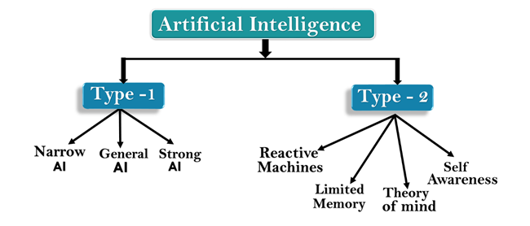
AI type-1: Based on Capabilities
1. Weak AI or Narrow AI:
- Narrow AI is a type of AI which is able to perform a dedicated task with intelligence.The most common and currently available AI is Narrow AI in the world of Artificial Intelligence.
- Narrow AI cannot perform beyond its field or limitations, as it is only trained for one specific task. Hence it is also termed as weak AI. Narrow AI can fail in unpredictable ways if it goes beyond its limits.
- Apple Siriis a good example of Narrow AI, but it operates with a limited pre-defined range of functions.
- IBM's Watson supercomputer also comes under Narrow AI, as it uses an Expert system approach combined with Machine learning and natural language processing.
Discuss the link between AI, ML and DL

Artificial Intelligence type-2: Based on functionality
1. Reactive Machines
- Purely reactive machines are the most basic types of Artificial Intelligence.
- Such AI systems do not store memories or past experiences for future actions.
- These machines only focus on current scenarios and react on it as per possible best action.
- IBM's Deep Blue system is an example of reactive machines.
- Google's AlphaGo is also an example of reactive machines.
2. Limited Memory
- Limited memory machines can store past experiences or some data for a short period of time.
- These machines can use stored data for a limited time period only.
- Self-driving cars are one of the best examples of Limited Memory systems. These cars can store recent speed of nearby cars, the distance of other cars, speed limit, and other information to navigate the road.
3. Theory of Mind
- Theory of Mind AI should understand the human emotions, people, beliefs, and be able to interact socially like humans.
- This type of AI machines are still not developed, but researchers are making lots of efforts and improvement for developing such AI machines.
4. Self-Awareness
- Self-awareness AI is the future of Artificial Intelligence. These machines will be super intelligent, and will have their own consciousness, sentiments, and self-awareness.
- These machines will be smarter than human mind.
- Self-Awareness AI does not exist in reality still and it is a hypothetical concept.

Explain how a ML model work?

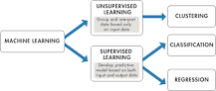

Supervised machine learning builds a model that makes predictions based on evidence in the presence of uncertainty. A supervised learning algorithm takes a known set of input data and known responses to the data (output) and trains a model to generate reasonable predictions for the response to new data.

